Name:______________________________________________
“The Cask of Amontillado” by Edgar Allen Poe
Date:___________________________
Period:________

mood: In a story, often an author will create a certain mood to prepare readers for what is to come. In “The Most Dangerous Game” Richard Connell created the mood for the story by describing the night as “moist black velvet.” The stories of “Ship Trap Island” where sailors were lured into a net of death also helped us prepare for what was to come later in that story. Edgar Allen Poe was the short story master of eerie, gruesome mood, since almost all of his stories took the reader through a maze to the certain, frightening death of a character.
mini-lesson
MOTIVE is why we do something. Detectives try to figure out WHY a victim was killed before they ever attempt to figure out WHO actually killed the person. In short stories, just as in real life, characters must have good reasons for doing whatever they do. Do we ever really find out what Montressor’s motive was in “The Cask of Amontillado”?

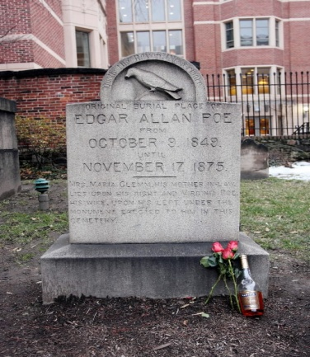
‘Poe toaster’ leaves flowers and a half full bottle of cognac every year on January 19

Poe’s death has been a mystery for years. Also a mystery is the identity of the “Poe toaster.” Since at least 1949 he has visited Poe’s grave, and no one has been able to identify him.
when one thinks of Edgar Allen Poe, he or she immediately thinks of mystery. The circumstances of his death are a mystery, and the identity of the person who visits his grave every year on the anniversary of his birth is a mystery too.
The “Poe toaster,” as he has come to be known, shows up every year on January 19, the date of Poe’s birth. He does the same thing each visit – he leaves red roses and a half-full bottle of expensive cognac at the grave.
It isn’t that no one has seen the toaster on his visits. In fact, year after year people camp out long before dark hoping to get a glimpse at whoever has been responsible for the tradition. Members of the Baltimore Poe Society have gone to great lengths to protect the toaster’s identity and never allow anyone close enough to confront him when he visits in the dark hours of the night. There was some speculation that the original toaster had retired from the role in 1993 when he left a note saying, “The torch will be passed.” Another note left five years later said his sons had taken over the tradition. Caretakers at the cemetery where Poe is buried, however, have said the way the man walks and his build lead them to believe that he is the same man who has always left the flowers and cognac.
over for study guide questions
Not everyone is buying the story of the Poe toaster, however. Many think it’s merely a publicity stunt to increase tourism related to Poe in Baltimore. Sam Porpora, a former Westminster Church historian, claims he started the toaster visit in the 1970s as a publicity stunt. Members of the Poe Society, however, point out articles about the toaster in the Baltimore Evening Sun as early as 1950, proving that the legend is at least that old.
It seems to fit Edgar Allen Poe’s style that the Poe toaster is just as much a mystery as the characters in the stories he wrote. Chances are Poe would enjoy the mystery surrounding the toaster.
“The Cask of Amontillado” study guide continued

1. Edgar Allen Poe was known for the eerie, gruesome atmosphere and mood in his short stories. List some things in “The Cask of Amontillado” that help create that mood in the story. (Hint: remember the kinds of things that created the same kind of mood in “The Most Dangerous Game”).
____________________________________________________________________________________________________________________________________________________________________________________________________________________________________________________________________________________________________________________________________________________

2. In order for a character in a story to be believable, the character must have a MOTIVE – a reason for doing what he or she does. What is Montressor’s motive for wanting to kill Fortunato? (Hint: re-read the opening paragraphs).
____________________________________________________________________________________________________________________________________________________________________________________________________________________________________________________________________________________________________________________________________________________

3. Point out at least two places in the story where Montressor seems to be trying to talk Fortunato out of going down the cellar. (Tell what Montressor says, give the page number, column and paragraph for each).
____________________________________________________________________________________________________________________________________________________________________________________________________________________________________________________________________________________________________________________________________________________

4. Why would Montressor do this (seem worried about Fortunato’s health) if he really wants to lead Fortunato down into the wine catacombs to kill him?
____________________________________________________________________________________________________________________________________________________________________________________________________________________________________________________________________________________________________________________________________________________

5. What is IRONIC about Fortunato’s name?
____________________________________________________________________________________________________________________________________________________________________________________________________________________________________________________________________________________________________________________________________________________

