BOOK REPORT - GRAPHIC NOVEL - Script It!  Select a Graphic Novel from the list of books that appear in the right hand column. Write a Movie Script for your favorite scene from the novel. Assign real-life TV or movie stars to play each of the characters. Storyboard the scene that you selected. See sample excerpts below for details.  The Lost World Story & Screenplay by Michael Crichton  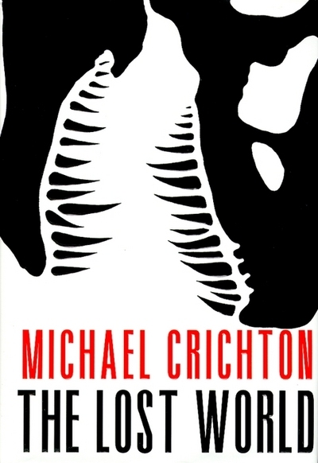  Sample Movie Script:  Favorite Scene from the Novel “The Lost World.”  Sample Storyboard:  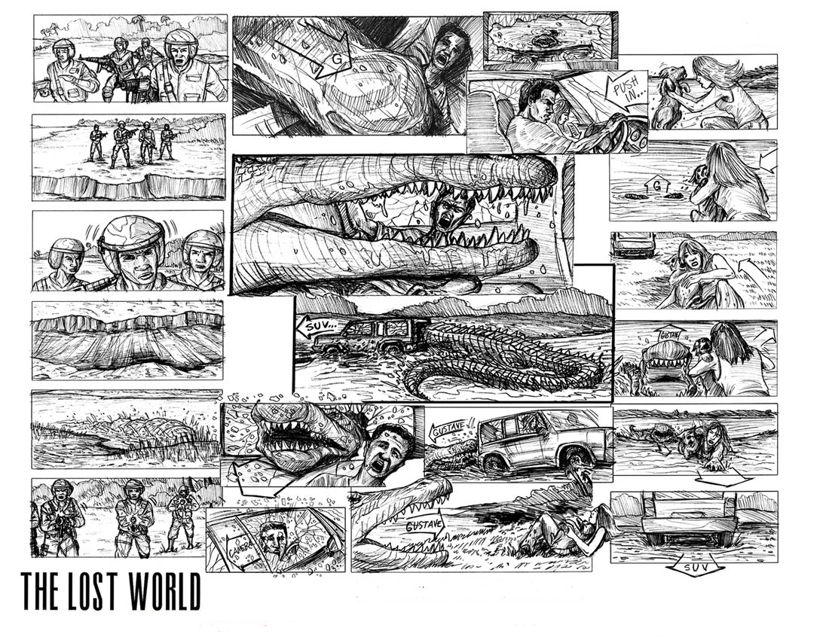  Story Characters Movie Star (Actor/Actress)  Eric Cooper Hugh Jackman  Amanda Kirby Lindsay Lohan  Billy Brennan Will Smith  EXT. RIVER BANK - CONTINUOUS - NIGHT  Eric notices something odd in the river.  ERIC  What's that?  The others look down in the murky water. Just below the surface,  A SHIMMERING WAVE OF SILVER passes beneath the boat.  ERIC  Something must've scared them.  WHAM!  The SUV is RAMMED, sending everyone tumbling.  SUPERCROC (Suchomimus)  rises from the water, towering over the Sports-Utility-Vehicle. As lightning FLASHES and thunder CRACKS, the prehistoric monster lets out an ear-splitting ROAR. (Continued on next page) | DUE DATE:_________  GRAPHIC NOVEL TITLES  A Contract with God by Will Eisner  Alias Vol. 1 by Brian Michael Bendis  American Born Chinese by Gene Luen Yang  Animal Man, "Deus Ex Machina"by Grant Morrison  Astro City: Life in the Big City by Kurt Busiek  Atomic Robo, Volume 1: by Brian Clevinger  Batman - "The Long Halloween" Written by Jeph Loeb  Batman: Dark Victory Written by Jeph Loeb  Batman: Year One by David Mazzucchelli  Batman: The Dark Knight Returns by Frank Miller  Beowulf by Gareth Hinds  Berlin: City of Stones by Jason Lutes  Blankets by Craig Thompson  Bone by Jeff Smith  Cairo by G. Willow Wilson  Captain America, Death of Vol. 1 by Ed Brubaker  Captain America, Death of Vol. 2 by Ed Brubaker  Catwoman: When in Rome by Jeph Loeb  Criminal (Vol. 1): Coward by Ed Brubaker  Crisis on Infinite Earths by Marv Wolfman and George Perez  Crossing Midnight, Vol. 1: Cut Here by Mike Carey  Dark Tower: Gunslinger Born by Peter David  Dark Tower: The Long Road Home by Peter David  Daredevil Omnibus, Vol. 1 by Ed Brubaker  Daredevil Omnibus Vol. 2 by Brian Michael Bendis & Alex Maleev  DMZ Vol. 1: On the Ground by Brian Wood  Ex Machina, Vol. 1: The First Hundred Days by Brian K. Vaughan  Exit Wouds Written by Rutu Modan  Fables: 1001 nights of snowfall by Bill Willingham  Fantastic Four: Books of Doom by Ed Brubaker  Ghost World by Daniel Clowes  Green Arrow: Year One by Andy Diggle  Green Lantern: The Sinestro Corps War, Vol. 1 by Geoff Johns  Green Lantern: The Sinestro Corps War, Vol. 2 by Geoff Johns  Hobbit, The by Charles Dixon (Adapter), J.R.R. Tolkien  Identity Crisis by Brad Meltzer  Incognegro by Mat Johnson  Incredible Hulk, The : Planet Hulk by Greg Pak  Invincible: The Ultimate Collection, Vol. 1 by Robert Kirkman  Invisibles, The Vol. 1: Say You Want a Revolution by Grant Morrison  Iron Man, Ultimate Vol. 1 by Orson Scott Card  Kingdom Come by Mark Waid  League of Extraordinary Gentlemen, The Vol. 1 by Alan Moore  Monster, Volume 1 by Naoki Urasawa  Mouse Guard Volume 1: Fall 1152 by David Petersen  Persepolis," by Marjane Satrapi  Powers Vol. 1: Who Killed Retro Girl? (Vol 1) by Brian Michael Bendis  Pride of Baghdad by Brian K. Vaughan  Rising Stars Vol. 1: Born in Fire by J. Michael Straczynsk  Sandman: Season of Mists by Neil Gaiman  Sleeper: Season One by Ed Brubaker  Spider-Man, Amazing Vol. 1: Coming Home by J. Michael Straczynsk  Superman, All Star Vol. 1 by Grant Morrison  Superman: Red Son (Elseworlds) by Mark Millar  Umbrella Academy Vol.1: Apocalypse Suite by Gerard Way  Usagi Yojimbo, Book 1: The Ronin by Stan Sakai  Usagi Yojimbo, Book 22: Tomoe's Story by Stan Sakai  V for Vendetta by Alan Moore  Walking Dead, Book 1 by Robert Kirkman  Watchmen by Alan Moore  Wolverine Origin (Vol. 1) by Paul Jenkins  Wolverine: Weapon X by Barry Windsor-Smith  X-Men: X-23, Astonishing - Innocence Lost by Craig Kyle  X-Men, New "E is For Extinction" by Grant Morrison  Y: The Last Man, Vol. 1: Unmanned by Brian K. Vaughan  Please Note: If you choose not to read a Graphic Novel from the list,  you still may choose to read a book of your choice just as long as it  is at a high school reading level (grades 9-12). Please do not report on  a book that you have already read in another English Class as well as  novels that we have read together in this course. Thank you.

