Name: _________________________________________ Date: ____________ Block: ______

To Kill a Mockingbird
Study Guide
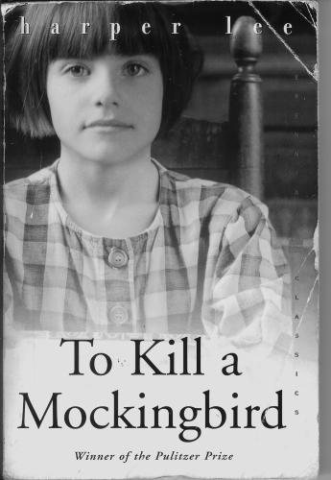
Directions: Complete the following questions, using evidence from the text when necessary.
Chapter 1
1. Where does the narrator live?
___________________________________________________________________
2. How old are Scout and Jem when the story begins?
___________________________________________________________________
3. Who is their new friend?
___________________________________________________________________
4. What is the name of the odd family in Maycomb?
___________________________________________________________________
5. Why does Jem touch the Radley house so much?
___________________________________________________________________

Chapter 2
1. How does Scout feel about starting school?
____________________________________________________________________________________________
2. What things does Scout do to get in trouble at school?
____________________________________________________________________________________________
3. Why won’t Walter Cunningham, Jr. take Miss Caroline’s quarter?
____________________________________________________________________________________________
4. How does Walter Cunningham, Sr. pay Atticus for his legal work?
____________________________________________________________________________________________

Chapter 3
1. What do Walter Cunningham and Atticus discuss at lunch?
____________________________________________________________________________________________
2. How does Calpurnia tell Scout to behave during lunch?
____________________________________________________________________________________________
3. What about Burris Ewell frightens Miss Caroline?
____________________________________________________________________________________________
4. What does Scout ask Atticus to do about her schooling?
____________________________________________________________________________________________
5. What compromise do Scout and Atticus reach about school?
___________________________________________________________________________________________

Chapter 4
1. Why does Jem push Scout extra hard in the tire?
___________________________________________________________________________________________
2. Where does Scout land?
___________________________________________________________________________________________
3. What new drama does Jem suggest they play?
___________________________________________________________________________________________
4. What are two reasons the new play acting makes Scout nervous?
___________________________________________________________________________________________
Chapter 5
1. What kind of relationship do the children have with Miss Maudie?
___________________________________________________________________________________________
2. What does Miss Maudie say about Boo Radley stories Scout repeats?
___________________________________________________________________________________________
3. How do Jem and Dill plan to give Boo Radley a note?
___________________________________________________________________________________________
4. What does the note say?
___________________________________________________________________________________________
5. What is Atticus’ reaction to the scheme?
___________________________________________________________________________________________

Name: _________________________________________ Date: ____________ Block: ______

To Kill a Mockingbird
Study Guide
Directions: Complete the following questions, using evidence from the text when necessary.

Chapter 6
1. What do Jem, Scout, and Dill do on Dill’s last night in Maycomb?
_____________________________________________________________________________________________
2. What does the man on the porch do?
_____________________________________________________________________________________________
3. What happens to Jem as they’re fleeing?
_____________________________________________________________________________________________
4. How does Dill explain the missing pants?
_____________________________________________________________________________________________
5. What does Jem do in the middle of the night?
_____________________________________________________________________________________________

Chapter 7
1. What does Jem tell Scout about his pants?
____________________________________________________________________________________________
2. What is Scout’s initial reaction to finding the soap carvings?
____________________________________________________________________________________________
3. What is Jem’s reaction?
____________________________________________________________________________________________
4. Why are they unable to fulfill their plan?
____________________________________________________________________________________________
5. How does Jem react to Nathan Radley’s actions?
____________________________________________________________________________________________
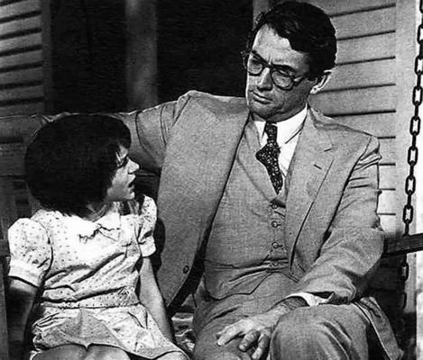
Chapter 8
1. What is Atticus’ reaction to the snowman’s likeness to Mr. Avery?
_____________________________________________________
2. What happens to Miss Maudie’s house?
_____________________________________________________
3. Where are Scout and Jem standing during the episode?
_____________________________________________________
4. What new item does Scout have in the morning?
_____________________________________________________
5. Where does it come from?
____________________________________________________________________________________________

Chapter 9
1. Why does Scout fight Cecil Jacobs?
____________________________________________________________________________________________
2. Who is Atticus defending?
____________________________________________________________________________________________
3. Why does Atticus feel he must take the case?
____________________________________________________________________________________________
4. Why is Atticus more concerned about Scout’s temper than her language?
_____________________________________________________________________________________________
5. What does Scout realize years later about the conversation between Atticus and Jack?
_____________________________________________________________________________________________

Chapter 10
1. In what ways is Atticus different from the fathers of Scout’s and Jem’s friends?
_____________________________________________________________________________________________
2. What does Atticus tell Jem about shooting mockingbirds?
_____________________________________________________________________________________________
3. What does Miss Maudie say about mockingbirds?
_____________________________________________________________________________________________
4. Who shoots Tim Johnson?
_____________________________________________________________________________________________
5. How does Jem react to that?
_____________________________________________________________________________________________

Name: _________________________________________ Date: ____________ Block: ______

To Kill a Mockingbird
Study Guide
Directions: Complete the following questions, using evidence from the text when necessary.

Chapter 11
1. What does Mrs. Dubose say that particularly upsets Jem?
_____________________________________________________________________________________________
2. What does Jem buy Scout?
_____________________________________________________________________________________________
3. What does Jem do when he passes by Mrs. Dubose’s house and she isn’t on the porch?
_____________________________________________________________________________________________
4. What is Jem’s punishment?
_____________________________________________________________________________________________
5. What pattern emerges in the afternoon reading sessions?
_____________________________________________________________________________________________

Chapter 12
1. What happens to Jem at age 12?
_____________________________________________________________________________________________
2. Why does Calpurnia take Scout and Jem to church with her?
_____________________________________________________________________________________________
3. What does First Purchase African M.E. look like?
_____________________________________________________________________________________________
4. How do other members of First Purchase behave?
_____________________________________________________________________________________________
5. How did Calpurnia learn to read?
_____________________________________________________________________________________________

Chapter 13
1. How does Aunt Alexandra spend her days in Maycomb?
_____________________________________________________________________________________________
2. Why does Aunt Alexandra usually regret asking Scout to come in and say hello to a visitor?
_____________________________________________________________________________________________
3. What is Atticus supposed to discuss with Scout and Jem?
_____________________________________________________________________________________________
4. How does Scout react when Atticus tells her to stop making noise with the comb?
_____________________________________________________________________________________________
5. What does Atticus tell the children at the end of the chapter?
_____________________________________________________________________________________________

Chapter 14
1. How does Atticus react to hearing about Scout and Jem’s visit to Calpurnia’s church?
_____________________________________________________________________________________________
2. Why does Scout start fighting Jem?
_____________________________________________________________________________________________
3. What does Scout find under her bed?
_____________________________________________________________________________________________
4. How does Jem break the code of childhood?
_____________________________________________________________________________________________
5. Why did Dill run away?
_____________________________________________________________________________________________

Chapter 15
1. What does Atticus take with him when he leaves Sunday evening?
_____________________________________________________________________________________________
2. Where do they find Atticus?
_____________________________________________________________________________________________
3. How does Jem react when Atticus tells the children to go home?
_____________________________________________________________________________________________

4. What is Scout trying to accomplish as she speaks to Mr. Cunningham?
_____________________________________________________________________________________________
5. What does the crowd do?
_____________________________________________________________________________________________

Name: _________________________________________ Date: ____________ Block: ______

To Kill a Mockingbird
Study Guide
Directions: Complete the following questions, using evidence from the text when necessary.

Chapter 16
1. How does everyone in the Finch household feel the next morning?
_____________________________________________________________________________________________
2. What does Atticus tell the children about coming downtown?
_____________________________________________________________________________________________
3. How does Mr. Dolphus Raymond differ from other what folk?
_____________________________________________________________________________________________
4. What new information does Scout learn about the Tom Robinson case?
______________________________________________________
______________________________________________________
5. Where do the children end up sitting?
_____________________________________________________

Chapter 17
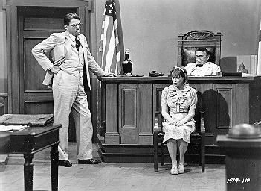
1. On which side is Mayella bruised?
____________________________________________________
2. How does Mr. Ewell behave on the witness stand?
____________________________________________________
3. How does the judge react to Mr. Ewell’s behavior?
____________________________________________________
4. What is Mr. Ewell’s testimony?
_____________________________________________________________________________________________
5. What does the reader learn when Mr. Ewell signs his name?
_____________________________________________________________________________________________

Chapter 18
1. What is Mayella afraid of when she first gets on the witness stand?
_____________________________________________________________________________________________
2. What areas does Atticus cover in the beginning of his questioning?
_____________________________________________________________________________________________
3. What is Mayella’s version of the events?
_____________________________________________________________________________________________
4. What is wrong with Tom’s arm?
_____________________________________________________________________________________________
5. Who does Atticus suggest beat Mayella?
_____________________________________________________________________________________________

Chapter 19
1. Who is Atticus’ only witness?
_____________________________________________________________________________________________
2. What is Tom’s version of the story?
_____________________________________________________________________________________________
3. What does Link Deas say when he interrupts his testimony?
_____________________________________________________________________________________________
4. What points does Mr. Gilmer make during his cross-examination of Tom?
_____________________________________________________________________________________________
5. Why does Dill begin crying?
_____________________________________________________________________________________________

Chapter 20
1. What do Scout and Dill learn about Mr. Dolphus Raymond?
_____________________________________________________________________________________________
2. What is happening when Scout and Dill return to the courthouse?
_____________________________________________________________________________________________
3. What are the main points in Atticus’ closing argument?
_____________________________________________________________________________________________
4. Who arrives at the courthouse as Atticus is finishing his speech?
_____________________________________________________________________________________________

Name: _________________________________________ Date: ____________ Block: ______

To Kill a Mockingbird
Study Guide
Directions: Complete the following questions, using evidence from the text when necessary.

Chapter 21
1. Why does Atticus change his mind about letting the children stay?
_____________________________________________________________________________________________
2. Who is in the courtroom when the children return after supper?
_____________________________________________________________________________________________
3. Scout’s feelings are reminiscent of what day?
_____________________________________________________________________________________________
4. What is the jury’s verdict?
_____________________________________________________________________________________________
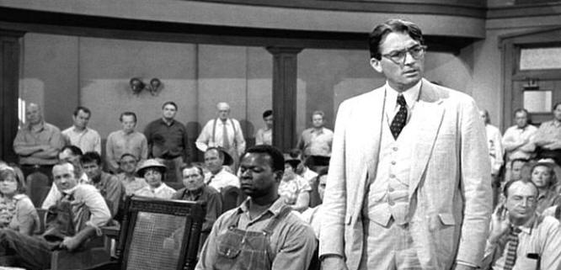
5. What does everyone in the balcony do when Atticus exits the courtroom?
________________________________________________
________________________________________________

Chapter 22
1. How does Jem react to the verdict?
_________________________________________________
2. Why does Atticus think it was acceptable for the children to be at the trial?
_____________________________________________________________________________________________
3. How doe Atticus respond to the gifts of food from the black community?
_____________________________________________________________________________________________
4. What things does Miss Maudie point out that Jem and Scout hadn’t realized?
_____________________________________________________________________________________________
5. What does Mr. Ewell do to Atticus?
_____________________________________________________________________________________________

Chapter 23
1. What is Atticus’ response to Mr. Ewell’s actions?
_____________________________________________________________________________________________
2. How do Jem and Scout feel about it?
_____________________________________________________________________________________________
3. What does Jem believe is the answer to the unjust trial verdict?
_____________________________________________________________________________________________
4. What does Atticus believe is the answer?
_____________________________________________________________________________________________
5. What is Aunt Alexandra’s response to Scout’s desire to invite Walter home?
_____________________________________________________________________________________________

Chapter 24
1. How does Scout behave during the refreshment period?
_____________________________________________________________________________________________
2. How does Miss Maudie help Scout during the questioning by Miss Stephanie?
_____________________________________________________________________________________________
3. How does Miss Maudie support Atticus?
_____________________________________________________________________________________________
4. What happends to Tom?
_____________________________________________________________________________________________
5. How do the ladies behave after Atticus and Calpurnia leave?
_____________________________________________________________________________________________

Chapter 25
1. What do Jem and Dill do on their way back from swimming?
_____________________________________________________________________________________________
2. How does Helen react to the news?
_______________________________________________________________
3. How long is Maycomb interested in the news of Tom’s death?
_________________________________________________________________
4. How does Mr. Underwood react to it?
_________________________________________________________________

Name: _________________________________________ Date: ____________ Block: ______

To Kill a Mockingbird
Study Guide
Directions: Complete the following questions, using evidence from the text when necessary.

Chapter 26
1. What does Scout thing about Boo Radley at this point?
___________________________________________________________________________________________
2. How do Scout’s and Jem’s peers act after the trial?
___________________________________________________________________________________________
3. What is bothering Scout about Miss Gates’ response to Hitler and the Jews?
___________________________________________________________________________________________
4. How does Jem react to Scout’s conversation with him?
___________________________________________________________________________________________
5. What is Atticus’ explanation for Jem’s behavior?
___________________________________________________________________________________________

Chapter 27
1. How does Link Deas help Helen Robinson?
___________________________________________________________________________________________
2. What did the Maycomb children do to the Misses Tutti and Frutti last Halloween?
___________________________________________________________________________________________
3. What is being done this year to prevent Halloween pranks?
___________________________________________________________________________________________
4. What is Scout’s role in the pageant?
___________________________________________________________________________________________
5. Who is escorting her to the school?
___________________________________________________________________________________________
Chapter 28
1. What is the night like as Jem and Scout’s walk to the school?
___________________________________________________________________________________________
2. What happens to Jem and Scout under the oak tree?
___________________________________________________________________________________________
3. How does Jem get home?
___________________________________________________________________________________________
4. What is Jem’s injury?
___________________________________________________________________________________________
5. What does Heck Tate find under the tree?
___________________________________________________________________________________________

Chapter 29
1. What does Aunt Alexandra say in response to these events?
___________________________________________________________________________________________
2. Why doesn’t Atticus hear Scout and Jem hollering?
___________________________________________________________________________________________
3. What happened to Scout’s costume?
___________________________________________________________________________________________
4. What strange sounds does the fourth person under the tree make?
___________________________________________________________________________________________
5. Who saves Scout and Jem?
___________________________________________________________________________________________

Chapter 30
1. Why do Scout and Boo go out to the porch?
___________________________________________________________________________________________
2. Who does Atticus think killed Mr. Ewell?
___________________________________________________________________________________________
3. Who does Heck Tate say killed Mr. Ewell?
___________________________________________________________________________________________
4. Why does Atticus want Jem’s name cleared legally?
_______________________________________________________________
5. Why doesn’t Heck Tate want to tell everyone the exact truth?
_______________________________________________________________
7. What does Scout say about this explanation of events?
_______________________________________________________________

Chapter 31
1. Why does Scout bring Mr. Arthur back inside?
_____________________________________________________________________________________________
2. How does Mr. Arthur behave toward Jem?
_____________________________________________________________________________________________
3. How does Mr. Arthur get home?
_____________________________________________________________________________________________
4. What does Scout do as she’s standing on Mr. Arthur’s porch?
_____________________________________________________________________________________________
5. Where does Atticus spend the night?
_____________________________________________________________________________________________

