Name: ________________________________________ Date: _________________ Period: _______
Romeo and Juliet Study Guide

Directions: Answer all the questions in complete sentences, using evidence from the text when necessary.

Prologue:
1. In what city does this play take place?
________________________________________________________

2. Why are Romeo and Juliet called “star-cross’d lovers”?
________________________________________________________
________________________________________________________
Scene 1:
3. Who is fighting at the beginning of the first scene?
________________________________________________________
4. Who tries to break up the fighting?
________________________________________________________
5. What threat does the Prince make to Lord Montague and Lord Capulet?
__________________________________________________________________________________________________________________________________________________________________________
6. Benvolio and Montague describe the way Romeo has been acting. What do they have to say about him?
__________________________________________________________________________________________________________________________________________________________________________

7. Why is Romeo so sad? Explain.
__________________________________________________________________________________________________________________________________________________________________________
8. What is Benvolio’s advice to Romeo?
__________________________________________________________________________________________________________________________________________________________________________

Scene 2:
9. Why does Capulet think it will be easy for Montague and him to keep the peace?
__________________________________________________________________________________________________________________________________________________________________________
10. What does Paris ask about Capulet?
__________________________________________________________________________________________________________________________________________________________________________
11. What is Capulet’s first answer?
__________________________________________________________________________________________________________________________________________________________________________
12. A bit later Capulet appears to change his mind about Paris’ question. What does he then tell Paris?
__________________________________________________________________________________________________________________________________________________________________________

13. What problem does the servant have?
__________________________________________________________________________________________________________________________________________________________________________
14. What is the name of the woman Romeo loves?
_____________________________________________________________________________________
15. What do Romeo and Benvolio decide to do?
_____________________________________________________________________________________

Scene 3:
16. How old is Juliet?
_____________________________________________________________________________________
17. When Lady Capulet asks Juliet how she feels about marriage, what is Juliet’s answer?
__________________________________________________________________________________________________________________________________________________________________________
18. Following Juliet’s answer, what does Lady Capulet then tell Juliet?
__________________________________________________________________________________________________________________________________________________________________________

Scene 4:
19. According to Mercutio, who or what is Queen Mab, and what does she or it do?
__________________________________________________________________________________________________________________________________________________________________________
20. What does Mercutio say about dreams?
_______________________________________________________________________________________________________________________________________________________________________________________________________________________________________________________________
21. What is Romeo’s mood at the end of this scene? Explain.
__________________________________________________________________________________________________________________________________________________________________________

Scene 5:
22. What does Romeo think of Juliet the first time he sees her?
__________________________________________________________________________________________________________________________________________________________________________
23. How does Tybalt recognize Romeo?
__________________________________________________________________________________________________________________________________________________________________________
24. When Tybalt is ready to seize Romeo and throw him out of the party, what does Capulet say to Tybalt?
__________________________________________________________________________________________________________________________________________________________________________
25. Explain what the conversation is between Romeo and Juliet.
___________________________________________
___________________________________________
___________________________________________
___________________________________________
___________________________________________
___________________________________________
26. How does Romeo find out Juliet’s last name?_____________________________________
27. How does Juliet find out Romeo’s last name?
___________________________________________

Name: ________________________________________ Date: _________________ Block: ________

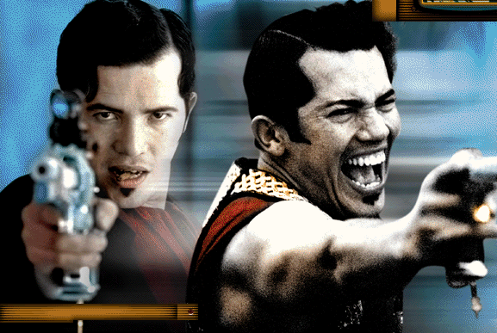
Romeo and Juliet Study Guide

Directions: Answer all the questions, using evidence from the text when necessary.

Act 11
Scene 1:
1. What does Mercutio say about “blind love”?
__________________________________________________________________________________________________________________________________________________________________________

Scene 2:
2. When Juliet appears on her balcony, what does Romeo compare her to?
__________________________________________________________________________________________________________________________________________________________________________
3. How does Juliet “speak, yet . . . [say] nothing”?
__________________________________________________________________________________________________________________________________________________________________________
4. When Juliet leans her cheek on her hand, what does Romeo say?
__________________________________________________________________________________________________________________________________________________________________________
5. Unaware of his presence, what does Juliet ask Romeo to say?
__________________________________________________________________________________________________________________________________________________________________________
6. In a sentence or two, explain what Juliet says about names.
_______________________________________________________________________________________________________________________________________________________________________________________________________________________________________________________________
7. Juliet asks how Romeo got into her place. The orchard walls are high, and Romeo’s life would be in danger if her relatives were to find him there. What is Romeo’s response to these questions?
__________________________________________________________________________________________________________________________________________________________________________
8. Why is Juliet embarrassed?
__________________________________________________________________________________________________________________________________________________________________________
9. Juliet is going to send someone to Romeo on the following day for what purpose?
__________________________________________________________________________________________________________________________________________________________________________

Scene 3:
10. What has friar Laurence been out gathering in his basket?
________________________________________________________________________________________________________________________________________________________________________
11. Explain lines 21-22: “Virtue itself turns vice, being misapplied,/And vice sometime by action dignified”?
_______________________________________________________________________________________________________________________________________________________________________________________________________________________________________________________________

12. When Friar Laurence sees Romeo, what comment does Friar Laurence make about seeing Romeo so early in the morning?
_____________________________________________________________________________________________________________________________________________________________________
13. What does Friar Laurence mean when he says to Romeo, “Young men’s love then lies not truly in their hearts, but in their eyes?
_____________________________________________________________________________________________________________________________________________________________________
14. Friar Laurence agrees to perform the marriage ceremony for Romeo and Juliet for what reason?
__________________________________________________________________________________________________________________________________________________________________________

Scene 4:
15. According to Mercutio, what kind of man is Tybalt?
__________________________________________________________________________________________________________________________________________________________________________
16. What is the nurse saying to Romeo in lines 157 – 163?
__________________________________________________________________________________________________________________________________________________________________________
17. How is Juliet to arrange to meet Romeo?
__________________________________________________________________________________________________________________________________________________________________________

Scene 5:
18. The nurse is supposed to be gone only a half hour, but she is actually gone for how long?
__________________________________________________________________________________________________________________________________________________________________________
19. How is the nurse behaving that is frustrating to Juliet?
__________________________________________________________________________________________________________________________________________________________________________
Scene 6:
20. What does Friar Laurence mean when he says, “Therefore, love moderately; long love doth so”?
__________________________________________________________________________________________________________________________________________________________________________

Name: ________________________________________ Date: _________________ Period: ______

Romeo and Juliet Study Guide

Directions: Answer all the questions, using evidence from the text when necessary.

Act III
Scene 1:
1. At the beginning of the scene, why does Benvolio think that there will be a fight?
__________________________________________________________________________________________________________________________________________________________________________
2. What does Mercutio accuse Benvolio of in lines 15-30?
__________________________________________________
__________________________________________________
__________________________________________________
__________________________________________________
__________________________________________________

3. When Tybalt and Mercutio first begin arguing, what does Benvolio tell them to do?
__________________________________________________________________________________________________________________________________________________________________________
4. What does Tybalt call Romeo?
_____________________________________________________________________________________
5. Why won’t Romeo fight Tybalt?
__________________________________________________________________________________________________________________________________________________________________________
6. What does Mercutio think is the reason Romeo refuses to fight?
__________________________________________________________________________________________________________________________________________________________________________
7. Why does Mercutio keep repeating, “A plague o’ both your houses”?
_____________________________________________________________________________________
_____________________________________________________________________________________
8. What does Romeo say that Juliet’s love has done to him?
__________________________________________________________________________________________________________________________________________________________________________
9. Why does Romeo call himself “fortune’s fool”?
_____________________________________________________________________________________
__________________________________________________________________________________________________________________________________________________________________________
10. When Benvolio relates to the Prince what happened, what does he say Romeo tried to before Mercutio was killed?
__________________________________________________________________________________________________________________________________________________________________________
11. What does Lady Capulet accuse Benvolio of? Why?
__________________________________________________________________________________________________________________________________________________________________________
12. What is Romeo’s punishment for killing Tybalt?
_____________________________________________________________________________________

Scene 2:
13. Why is Juliet so impatient for the nurse to return?
__________________________________________________________________________________________________________________________________________________________________________
14. Describe Juliet’s rapidly changing attitudes toward Romeo in this scene.
_______________________________________________________________________________________________________________________________________________________________________________________________________________________________________________________________
15. What piece of news has upset Juliet the most?
__________________________________________________________________________________________________________________________________________________________________________
16. What does the nurse promise to do?
_____________________________________________________________________________________
Scene 3:
17. Explain Romeo’s reaction to the news of his banishment.
__________________________________________________________________________________________________________________________________________________________________________
18. Romeo tells Friar Laurence that the priest cannot know or understand how Romeo feels. Why?
_______________________________________________________________________________________________________________________________________________________________________________________________________________________________________________________________
19. What argument does Friar Laurence use to prevent Romeo from killing himself?
__________________________________________________________________________________________________________________________________________________________________________
20. What does the nurse give to Romeo?
__________________________________________________________________________________________________________________________________________________________________________

Scene 4:
21. What does Capulet tell his wife to say to Juliet?
__________________________________________________________________________________________________________________________________________________________________________

Scene 5:
22. As Romeo is preparing to leave Juliet, what argument does she use to convince him to stay?
________________________________________________________
________________________________________________________
________________________________________________________
________________________________________________________
23. Later, why does Juliet think Romeo should leave?
________________________________________________________
________________________________________________________
24. Just as Romeo is about to descend the rope ladder and leave Juliet, what does Juliet say about the way Romeo looks?
________________________________________________________
________________________________________________________
25. Why does Lady Capulet think Juliet is crying?
________________________________________________________
26. When Lady Capulet threatens to send someone to Mantua to poison Romeo, what does Juliet say?
__________________________________________________________________________________________________________________________________________________________________________
27. After Lady Capulet breaks the news about Paris, what is Juliet’s response?
__________________________________________________________________________________________________________________________________________________________________________
28. If Juliet’s mother does not arrange to delay the marriage, what will Juliet do?
__________________________________________________________________________________________________________________________________________________________________________
29. What is Capulet’s reaction to Juliet’s threats?
__________________________________________________________________________________________________________________________________________________________________________
30. What is the nurse’s advice to Juliet?
__________________________________________________________________________________________________________________________________________________________________________
31. How does Juliet’s attitude toward the nurse change?
__________________________________________________________________________________________________________________________________________________________________________
32. What “scheme” does Juliet devise to get rid of the nurse and to get out of the house?
__________________________________________________________________________________________________________________________________________________________________________

Name: ________________________________________ Date: _________________ Period: ______
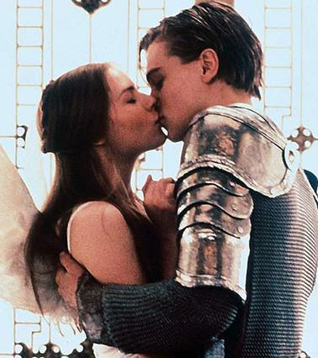
Romeo and Juliet Study Guide

Directions: Answer all the questions, using evidence from the text when necessary.

Act IV
Scene 1:
1. Why is Friar Laurence reluctant to marry Paris to Juliet?______________________________________________
___________________________________________________
___________________________________________________
2. How does Paris explain the sudden haste of the marriage plans?
__________________________________________________________________________________________________________________________________________________________________________
3. What is ironic about the conversation between Juliet and Paris?
__________________________________________________________________________________________________________________________________________________________________________
4. If Friar Laurence cannot help her, what does Juliet threaten to do?
__________________________________________________________________________________________________________________________________________________________________________
5. Why does Friar Laurence think that Juliet will accept his plan?
__________________________________________________________________________________________________________________________________________________________________________
6. Describe the friar’s plan for Juliet.
____________________________________________________________________________________________________________________________________________________________________________________________________________________________________________________________________________________________________________________________________________________

Scene 2:
7. What does Juliet say that makes her father happy?
__________________________________________________________________________________________________________________________________________________________________________
8. How does Capulet change the wedding plans? What implication does this have?
__________________________________________________________________________________________________________________________________________________________________________

Scene 3:
9. How does Juliet show her maturity and independence in this scene?
__________________________________________________________________________________________________________________________________________________________________________
10. If the potion does not work, what will Juliet do?
__________________________________________________________________________________________________________________________________________________________________________

11. What are some of the fears Juliet has about the potion?
__________________________________________________________________________________________________________________________________________________________________________

Scene 4:
12. What is happening in this brief scene?
_______________________________________________________________________________________________________________________________________________________________________________________________________________________________________________________________

Scene 5:
1. Describe the imagery Shakespeare uses in describing Juliet’s “death”?
_______________________________________________________________________________________________________________________________________________________________________________________________________________________________________________________________
2. What does Friar Laurence say to comfort the Capulet family?
__________________________________________________________________________________________________________________________________________________________________________
3. What event are the Capulets now preparing for?
__________________________________________________________________________________________________________________________________________________________________________

Name: ________________________________________ Date: _________________ Period: ______

Romeo and Juliet Study Guide

Directions: Answer all the questions, using evidence from the text when necessary.

Act V
Scene 1:
1. What news does Balthasar bring Romeo?
__________________________________________________________________________________________________________________________________________________________________________
2. What does Romeo mean when he says, “Then I defy you, stars!”?
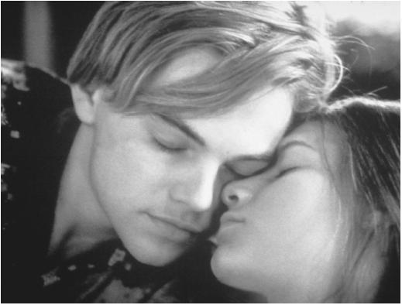
_________________________________________________________
_________________________________________________________
_________________________________________________________
3. What actions does Balthasar’s news prompt Romeo to do?
________________________________________________________
________________________________________________________

Scene 2:
4. What does Friar John tell Friar Laurence?
________________________________________________________
________________________________________________________
5. After hearing this news from Friar John, what does Friar Laurence intend to do?
__________________________________________________________________________________________________________________________________________________________________________

Scene 3:
6. Why is Paris at Juliet’s tomb?
__________________________________________________________________________________________________________________________________________________________________________

7. Romeo gives Balthasar two reasons for entering the Capulet’s tomb. What are those two reasons?
__________________________________________________________________________________________________________________________________________________________________________
8. Why does Paris think that Romeo has come to the tomb?
__________________________________________________________________________________________________________________________________________________________________________
9. What is it about Juliet that should have told Romeo that she was not dead?
__________________________________________________________________________________________________________________________________________________________________________
10. Why doesn’t Friar Laurence stay in the tomb with Juliet after she awakens?
__________________________________________________________________________________________________________________________________________________________________________
11. Why does Juliet kiss Romeo after he is dead?
__________________________________________________________________________________________________________________________________________________________________________
12. When Montague first arrives on the scene, what does he tell those gathered?
__________________________________________________________________________________________________________________________________________________________________________
13. Relate the events that lead to Romeo and Juliet’s death as they are told by Friar Laurence near the play’s end.
_______________________________________________________________________________________________________________________________________________________________________________________________________________________________________________________________
14. What information does Romeo’s letter give?
__________________________________________________________________________________________________________________________________________________________________________
15. How do Montague and Capulet plan to honor the memories of their children?
__________________________________________________________________________________________________________________________________________________________________________

