Greek Mythology ~ Notes
Gods &Goddesses

How It All Began
There was an importance to people for some explanation of how the world began and how its people came to exist. Therefore, all ancient societies developed a creation myth. For example, American Indians imagined that their world had been created by an animal. This was a natural assumption since they lived closely with the animals and depended on them for their very existence.
The Greeks had a different explanation. They believed that Chaos was the first state of the world and of the universe. As you might guess from the world chaos, no order existed, and there was no light.
From this nothingness arose Nyx (night) and Erebus (the personification of darkness). Next came Eros, which represented both love and the principle of order. (In later myths, Eros became the god of love.)
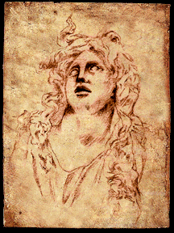
Finally, Eros achieved harmony (order) by bringing together Gaea, or Earth (the female force ~ notice how we call Nature “Mother Nature”), Uranus, or Sky (the male force). From their union came three hundred-handed monsters, three one-eyed giants, and the Titans.
Gaea
Gaea is also credited with producing the mountains and seas, but it is her Titan children who are of special interest to us because although they were giants, they were human in form. Thus, the Greeks had begun to imagine their gods to be like themselves in appearance.
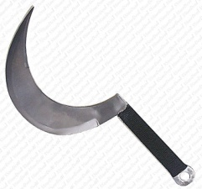
Cronus was the youngest of these Titans. He was destined to cause his father’s fall from power.
Uranus, Cronus’s father, was terrified of his giant children and fearful they would overthrow him. To prevent that, he had been burying them alive. Gaea, their mother, was powerless to stop him. Finally, she persuaded Cronus to take revenge for his brothers and sisters. In anger, Cronus took a sickle, mutilated his father, and then seized the position of supreme ruler.
Certainly, Uranus seems to have been an unnatural father and Cronus an unnatural son, but actually their behavior is symbolic, not only of the Greek way of life, but also perhaps of our own. Eventually, don’t the children (the new generation) replace the parents? Haven’t we seen old governments overthrown or replaced by a new one? Even in business, aren’t the older executives or leaders forced to move out to make way for “young blood”?
Sickle
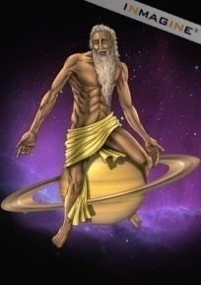
Perhaps the Greek account isn’t as fanciful as it first appears.

The Gods Give Way To The New
Now you may be wondering when human beings entered the picture. Actually that did not take place until after another power struggle among the gods.
Cronus
It happened just like this. Cronus was now in power, but just like his father before him, he saw everyone else as a threat to his throne. As a result, he decided to leave the three hundred-handed monsters and the one-eyed giants buried. He released only his fellow Titans.
He was suspicious of his own children, too, but instead of burying them alive as Uranus had done, he ate them! Cronus’s wife, Rhea, tolerated his behavior for a while. Then, like Gaea, she plotted against her husband. Just after Rhea had given birth to a son, Zeus, she arranged for him to be taken to a distant place where he would be safe from his father. Then she wrapped a large stone in a cloth, and the unsuspecting Cronus ate it, thinking that he was destroying his latest son.
When Zeus had grown to manhood, he returned home unrecognized. Then he found a way to feed Cronus an herb which caused him to vomit violently, thus releasing the eleven children he had swallowed long before.
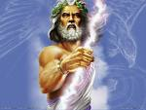
Zeus now had eleven allies, and he also enlisted the help of two sympathetic Titans, Prometheus and Epimetheus. Next, he released the one-eye giants, or Cyclopes, who had been buried all this time knowing that they too would have a grudge against Cronus. Even with all those allies, Zeus found his father to be a formidable opponent. Their power struggle lasted ten long years, but finally Cronus was deposed and Zeus became the supreme leader.
Like many real-life conquering heroes, Zeus rewarded his followers in various ways, but he divided his father’s kingdom with his two brothers. Poseidon was to be god of the sea; and Hades, god of the Underworld. Naturally, Zeus kept the best for himself and became the god of the sky and upper world.
Zeus

Zeus & His Brothers
Know we know that Zeus was clever. Remember how he fed his unsuspecting father an herb so that Cronus would disgorge his children? Zeus was also aggressive and ambitious, a fighter who did not hesitate to dispose his father and take over the throne. And he was also cruel and relentless.
But, for the Greeks, Zeus was the supreme god. We can assume that these qualities he displayed were ones they saw as necessary in a leader.
Zeus was also a father figure. The Greeks believed that he determined how human beings should behave and punished wrongdoers. They feared his wrath and the thunderbolts he could hurl from the sky.
But Zeus had human failings, too. He was often unfaithful to his wife and had love affairs with mortal maidens. Here is evidence that the Greeks endowed their gods with both the good and bad traits they themselves possessed.
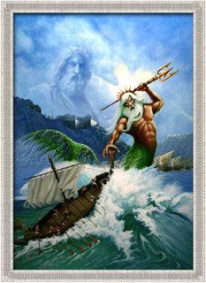


Zeus’s brother Poseidon was also a powerful and wrathful god, restless as the sea, which was his home. To the Greeks, whose land was nearly surrounded by water, he was important because in his good moods he protected navigation and commerce. In his bad moods, however, he caused storms and earthquakes. Like Zeus, he was relentless toward those who offended him – as the hero Odysseus discovered. Having blinded Poseidon’s one-eyed son, Polyphemos, Odysseus was doomed to roam the seas for ten years before he was allowed to return home on the island of Ithaca.
Poseidon

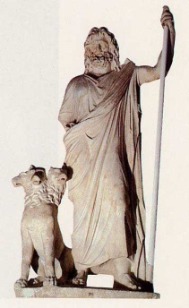


Hades, guardian of the Underworld, was a shadowy figure. Black-cloaked and gloomy, he seemed as mysterious as the infernal regions where he dwelt and whose gates were guarded by the many-headed dog, Cerberus. But the Greeks believed that he protected the harvests, and they know that his kingdom yielded great riches in minerals and metals.
Hades
Hades acted merely as the custodian of the dead; it was not his role to decide the fate of those who came into his domain. Three judges did that. Yet he was so feared that his name was seldom mentioned. Since he offered no threat of punishment and he almost never left the Underworld, the fear of him was just a reflection of the fear of death. For the Greeks, the afterlife offered little reward, even for those whose life on earth had been exemplary.

The Major Goddesses
Hera, one of Zeus’s three sisters, became his wife. She was the queen of the heavens and the goddess of marriage and childbirth. The Greeks imagined her as a nagging wife – beautiful, but vain and vindictive. They told many stories of her cruelty to any girl who happened to arouse her husband’s interest.
The peacock was Hera’s favorite bird. The design on its tail feathers represented the hundred eyes of Argus, which Hera had transplanted there to help her keep watch over Zeus.
Hera
Demeter was also a sister of Zeus. You may remember the story of Hades’s kidnapping of her daughter, Persephone. It was said that as Demeter roamed the earth mourning for her daughter, she lit two torches and with them set fire to Mount Etna. Its volcano is still active today.
The third sister, Hestia, was not given the prominence of the other two. She was the goddess of the hearth fire and a protectress of the household and the people themselves.
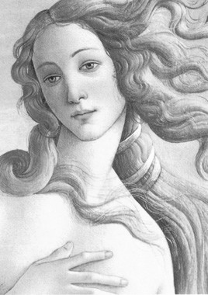
Aphrodite, the goddess of love and beauty was even lovelier than Hera, which did not endear her to that vain immortal. Ironically, Aphrodite was married to a physically unattractive Hephaestus, blacksmith to the gods. Like Zeus, who some say myths is said to be like her father, she was unfaithful in marriage and had many love affairs. It is clear that the Greeks considered her basically immoral; but despite that weakness in her character, they admired her beauty and believed she personified peace, unity, and order. Appropriately, the white dove is her symbol.
Aphrodite
Aphrodite is supposed to have been born from the foam of the sea, but the goddess Athena had an even more unusual birth. She is supposed to have sprung to life from Zeus’s forehead, fully grown, completely clothed, and armed for battle.
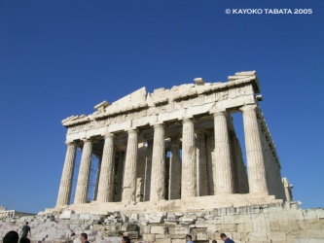
The child of Zeus’s brain, Athena became the goddess of wisdom, with the owl as her symbol. In some myths, she is credited with helping Prometheus bring the sacred fire to man. At any rate, she was much admired by the Greeks, who named Athens after her and built the Parthenon in her honor.
Artemis, also a daughter of Zeus, was the moon goddess. The Greeks imagined her as a young and beautiful huntress, changeable in form and nature. She was sometimes friendly, protecting virgins and travelers. She was a patroness of marriage and a helper in childbirth. But she could cause sudden death, shooting unlucky females with her arrows, and she was believed to cause madness (craziness). Truly, she was an unpredictable goddess.
Parthenon
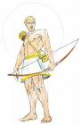
Other Great Olympians
Apollo, the sun god, was especially important to farmers, but important to the seagoing Greeks, too, because he guided navigators. He had many powers: as a healer of the sick and protector of the crops, as a shepherd, as a musician, and as the patron of oratory, art, poetry, and science. The Greeks held him in such esteem that they built a temple at Delphi in his honor; its oracle became famous throughout the ancient world. TI was believed that Apollo had gone down into darkness and risen again; thus, he became a symbol of resurrection and eternal life. He also represented order, purity, and reasonableness.
Apollo
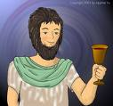
Another god, Dionysus, also experienced a kind of death and rebirth. He represented the earth itself as it went through the cycle of fall, winter and spring. He was best known, though, as the god of wine, and wine played an important part in the life of the Greeks.
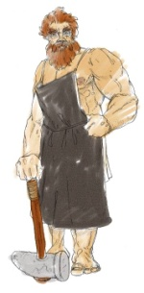
The stories of Dionysus’s birth vary, but in one he is the child of Zeus and Semele, one of Zeus’s many mortal lovers. In another story, jealous Hera is supposed to have driven him mad. At any rate, wherever Dionysus went, he was followed by frenzied females dressed in animal skins. Their wild and noisy behavior (from which our word orgy comes) caused him to be associated with intoxication. But he was also credited with teaching the Greeks how to cultivate their crops. He was the god of fertility and of inspiration. His festival, held each year in Athens, was actually a literary contest at which Greek tragedies and comedies were first performed.
Dionysus
There was the god Hephaestus, blacksmith of the gods and husband of Aphrodite. He was an outcast among the gods because he was lame and ugly, he was a great craftsman who produced armor for heroes, fashioning it on his anvil located in Mount Etna. The volcano’s sparks were said to come from his forge.
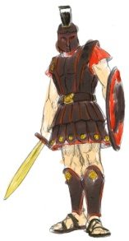
One of his rivals for the affection of Aphrodite was Ares, god of war. In the myths, Ares appears as a fickle, bloodthirsty, and bullying character, with no redeeming features. He was the twin brother of Eris (strife). His horses were Deimos (panic) and Phobos (fear). It is a contradiction that although the Greeks revered their military heroes, they disliked the god of war. Evidently, they saw war as an ugly necessity.
Hephaestus
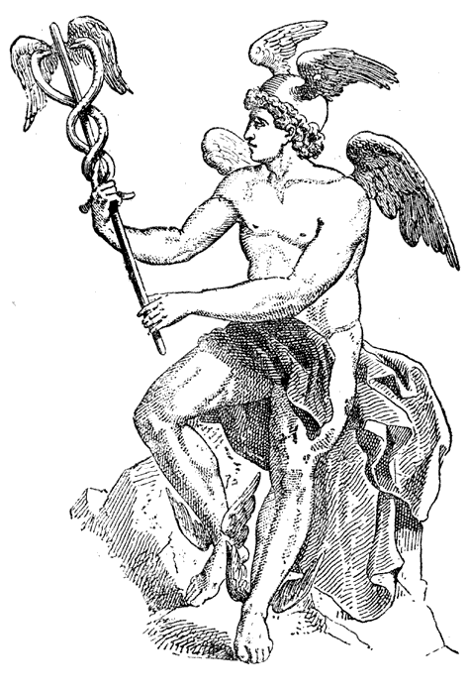
The last of the great Olympians is one whose physical form is probably familiar to you. He is Hermes, the well-known symbol of the Florists’ Transworld Delivery system. He was the messenger of the gods and represented the wind, which he resembled in his swiftness and his unpredictability. His functions offer an indication of his character. He was the go-between for the living and the dead and escorted souls down to Hades. He was the god of commerce and science and of luck and wealth, but he was also the patron of thieves and vagabonds. He invented the lyre and give it to his brother Apollo, but only after he had stolen Apollo’s oxen. In short, like the Greeks themselves, he had both good and bad traits.
Ares
Hermes

When Gods Walked the Earth
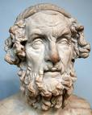
About 800 B.C., the Greek poet Homer wrote two famous epic poems. One, The Iliad, was the story of the great war between the Greeks and the Trojans. The other, The Odyssey, was the story of one Greek warrior, Odyssesus, and his long period of wandering after the Trojan War. These two poems are considered the oldest written literature in the Western world, but we know that a long tradition of oral poetry and storytelling preceded them.
Homer
Homer retells some to the myths in his two poems; but The Iliad and The Odyssey also give us a great deal more information about how the Greeks lived and thought. The reader soon recognizes that the people imagined the gods might be walking among them at any time. Knowing that the gods often assumed human disguises, the Greeks treated all strangers kindly and generously.
For example, a stranger who came to a house was fed and given a chance to bathe before anyone inquired as to his name or business. Upon leaving, the guest was given a “stranger’s gift” as a memento of the visit. For the Greeks, hospitality was an art as well as a religious duty.
But the Greeks has their share of human failings. They gradually became lax in their observations of the rules of hospitality. Even worse, they began to neglect to make sacrifices to the gods. At this point, Zeus decided to teach them a lesson. He sent a nine-day deluge to destroy these godless people who had ceased to be reverent.
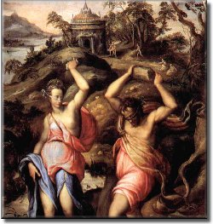
Only one aged couple survived this terrible flood. They were Deucalion (son of Prometheus) and his wife Pyrrha (daughter of Epimetheus and Pandora). Accounts vary as to why these two were saved. One story is that when Zeus was wandering the earth in disguise, Deucalion and Pyrrha were the only people to show him hospitality. Another myth says that Prometheus warned his son about the impending disaster. Deucalion then built a great floating chest or ark and stowed enough food on it so that he and Pyrrha could survive until the waters receded.
When the waters did recede, Deucalion and Pyrrha found themselves alone and lonely, Zeus then spoke to Deucalion through an oracle, telling him to cast behind him the bones of his mother. The two old people, puzzled at first, eventually interpreted the advice. The oracle’s words referred to Mother Earth, whose bones were the rocks. These they cast over their shoulders. Each one that Pyrrha threw became a woman and each one the Deucalion threw became a man. Thus, in a sense, Deucalion and Pyrrha became the parents of a new race of people, reverent and god-fearing like themselves.
Deucalion & Pyrrha
In this story, you’ve met Zeus in a new guise – as a stern and just father, laying down the rules for his people’s behavior, punishing those who disobey, and rewarding those who are obedient.
Athena, too, was actively involved with the lives of mortals. In The Odyssey, she fights side by side with the hero, Odysseus. She takes a personal interest in Odysseus’s son, Telemachus, urging him to action, sometimes by scolding and sometimes by building his confidence. She comforts Odysseus’s wife, Penelope. In short, she is a friend and ally to Odysseus and his family.
Zeus and Athena were not the only gods who walked the earth. Demeter also wandered from land to land after she lost Persephone. Dionysus and his followers were believed to inhabit the woodlands, as was Pan, god of the fields and forests. In fact, the Greeks believed spirits existed everywhere – lesser gods than the great Olympians, but immortals all the same. Beautiful, immortal maidens called nymphs lived in mossy glens and flowering fields; and others called naiads lived in sparkling streams. In other words, the gods were part of the natural world.

Achilles and Odysseus, Homer’s Warrior-Heroes
In the long poems The Iliad and The Odyssey, the ancient Greek poet Homer makes the heroes Achilles and Odysseus so believable that readers are inclined to judge their actions just as they might judge people they know. A few incidents from their stories follow. After you have read them, you may decide that you like one hero better than the other.



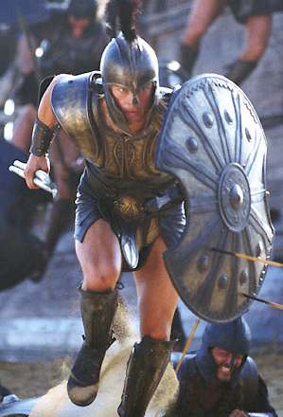
In the 24 books (chapters) of The Iliad, which is the story of the Trojan War, Achilles inspires his comrades with his bravery. Unfortunately, he quarrels with the commanding general, A gamemnon, who has taken a fancy to Achilles’s slave girl and wants her for himself. Sulkily, Achilles withdraws from battle and remains in his tent. Without him, the Greeks’ morale is so low that the tide of battle turns in the Trojan’s favor.
Achilles’s best friend then borrows his armor and goes onto the battlefield, hoping the Trojans will mistake him for Achilles and lose courage. The trick works, but Achilles’s friend is killed by the Trojan prince Hector. Wild with grief, Achilles vows revenge; but he must have armor before he can go onto the battlefield.
At this point, Achilles’s mother, Thetis, intervenes. You may recall when he was an infant; she dipped him in the River Styx, hoping to make him invulnerable. Ever protective, she had tried to prevent him from entering the Trojan War because it had been prophesied that he would die on the battlefield. Now, she persuades Hephaestus to make new armor for him. Wearing it, Achilles charges onto the battlefield, driving the Trojans before him.
Achilles
Only Hector refuses to retreat behind the city walls. Achilles now takes revenge. Three times he chases Hector around the walls of Troy, at last killing him with a spear. Fierce in his anger and grief, he then drags Hector’s body three times more around those walls for all the Trojans to see. But, in a more merciful mood, he later releases the body to Hector’s father, King Priam, and declares a temporary truce for the funeral rites.

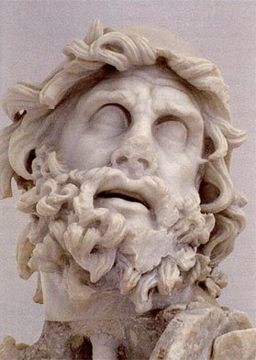


Odysseus, the hero of The Odyssey, is very different from Achilles. He is less emotional, less impetuous, more clever and crafty, less merciful, and more foolhardy.
Because he offends the gods in two ways, by stealing the statue of Athena from Troy and by blinding Poseidon’s one-eyed son, the Cyclops Polyphemos, he is doomed to trials and tribulations on his long journey from the Trojan War.
Odysseus
In the Cyclops incident, Odysseus lingers at Polyphemos’s cave to get his “stranger’s gift,” even though his men beg him to leave. This costs him several followers, who the Cyclops eats. But through Odysseus’s cleverness, the remaining men escape from the cave here Polyphemos had held them prisoner. As they sail away, however, Odysseus taunts the now-blind giant. Polyphemos retaliates by throwing rocks at the ship, almost causing disaster for Odysseus and his crew.
Unlike Agamemnon and Achilles, who argued over the slave girl, Odysseus seems relatively indifferent to the women he meets and determined to return to his wife, Penelope. He eventually leaves the beautiful witches Circe and Calypso and declines to marry the love princess Nausicaa.
When he finally arrives home, the finds Penelope still faithful to him, kills all the false suitors who have been trying to marry her, and murders all the female servants how have not been loyal to him and their mistress.
During his journey, Odysseus goes down into the Underworld and returns, determined to appease Poseidon. In fact, throughout his travels he remains obedient to the gods. Homer has made him the most complex and human of heroes. Odysseus called him “Noman.” He is every man.

